### A PROJECT REPORT ON

**Pixel Pen (A High-Performance Full-Stack Platform)** Submitted for partial fulfilment of the Requirements for the Degree Of **MASTER OF COMPUTER APPLICATION**

**Session (2024-25) Submitted by**

**AHMAD FARAZ ANSARI**

**(University Roll No: 2023073006) ANJALI CHAUDHARY**

**(University Roll No: 2023073010) SHUBHAM**

**(University Roll No: 2023073062) Under the Supervision of** Supervisor

**DR. JAY PRAKASH (PROFESSOR, ITCA)**

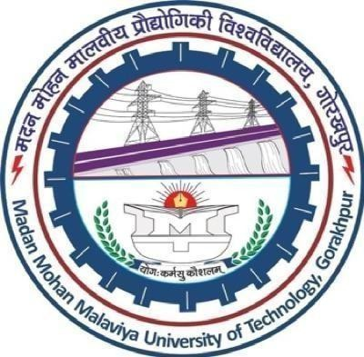

**Department of Information Technology & Computer Application Madan Mohan Malaviya University of Technology,**

**Gorakhpur Uttar Pradesh 273010, INDIA (MAY 2025)**

# CERTIFICATE

This is to certify that the project report titled **"Pixel Pen (A High-Performance Full-Stack Platform)"** submitted by **AHMAD FARAZ ANSARI (University Roll No:2023073006) ANJALI CHAUDHARY (University Roll No:2023073010) SHUBHAM (University Roll No:2023073062)** to Madan Mohan Malaviya University of Technology in partial fulfilment of the requirements for the award of the degree of Masters of Computer Application is a Bonafide record of the work carried out by him under my supervision.

**Supervisor**

**Dr. Jay Prakash Professor,**

**Department of Information Technology & Computer Application MMMUT, GORAKHPUR**

**Date:**

# CANDIDATE'S DECLARATION

We here declare that the report "**Pixel Pen (A High-Performance Full-Stack Platform)**" submitted to **Madan Mohan Malaviya University of Technology Gorakhpur** is entirely our own work. We certify that to the best of my belief and knowledge, it has no material that has been published or written by someone else previously, or any material that has been accepted for the award of any other diploma or degree from this institution or any other higher learning institution, except where acknowledgement has been made in the work.

Sign.:

Student Name: AHMAD FARAZ ANSARI (University Roll No: 2023073006)

Sign.:

Student Name: ANJALI CHAUDHARY (University Roll No: 2023073010)

Sign.:

Student Name: SHUBHAM (University Roll No: 2023073062)

Date:

# APPROVAL SHEET

This project report entitled **"Pixel Pen (A High-Performance Full-Stack Platform)"**

submitted by **AHMAD FARAZ ANSARI** (2023073006), **ANJALI CHAUDHARY** and

(2023073010) **SHUBHAM** (2023073062) is approved for the degree of Master of Computer Applications, ITCA, MMMUT, GORAKHPUR, 273010.

**External Examiner**

**Supervisor**

**Dr. Jay Prakash Professor,**

**Department of Information Technology & Computer Application MMMUT, GORAKHPUR**

**Head of Department Prof. D. S. Singh Professor & HOD,**

**Department of Information Technology & Computer Application MMMUT, GORAKHPUR**

**Date:**

**Place:**

# ACKNOWLEDGEMENT

It is indeed a great pleasure to express our sincere thanks to our supervisor **Dr. Jay Prakash, Professor**, Department of Information Technology & Computer Application, Madan Mohan Malaviya University of Technology, Gorakhpur for his valuable advice and pragmatic views of the project. His keen interest, sincere advice, and kind help throughout during the completion of this work had been a regular source of encouragement. We are thankful to **Prof. D. S. Singh**, Head of Department of Information Technology & Computer Application for providing us department labs and terminals for our Project and other teachers of Department of Information Technology & Computer Application for their friendly treatment and cooperation in the valuable advice and suggestion.

We are indebted to our parents who raised us to be self-assured and well-balanced person and always had faith in our capability to complete the things we initiated. We are also thankful to Almighty who provided us with the strength and health for the completion of the work.

Sign.:

AHMAD FARAZ ANSARI (Roll No: 2023073006)

Sign.:

ANJALI CHAUDHARY (Roll No: 2023073010)

Sign.: SHUBHAM

(Roll No: 2023073062)

# LIST OF ABBREVIATIONS

**API** - Application Programming Interface

**AWS** - Amazon Web Services

**B2C** - Business to Consumer

**CI/CD** - Continuous Integration / Continuous Deployment

**CRUD** - Create, Read, Update, Delete

**CSS** - Cascading Style Sheets

**DB** - Database

**DNS** - Domain Name System **GCP** - Google Cloud Platform **Git** - Version Control System

**HTML** - Hypertext Markup Language **HTTP** - Hypertext Transfer Protocol **HTTPS** - Hypertext Transfer Protocol Secure **IP** - Internet Protocol

**JS** - JavaScript

**JSON** - JavaScript Object Notation

**JWT** - JSON Web Token

**MERN** - MongoDB, Express.js, React.js, Node.js **MongoDB Atlas** - Cloud-based MongoDB service **NoSQL** - Not Only SQL

**NPM** - Node Package Manager **Render** - Platform for backend deployment **REST** - Representational State Transfer **SDK** - Software Development Kit

**SEO** - Search Engine Optimization

**SSL** - Secure Sockets Layer

**UI** - User Interface

**UX** - User Experience

**Vercel** - Platform for frontend deployment

**VPC** - Virtual Private Cloud

# LIST OF FIGURES

**Page No.**

1. Figure 1: Level 0 DFD 11
2. Figure 5: Flowchart of Pixel Pen 12
3. Figure 6: Home screen in light mode 24
4. Figure 7: Home screen in dark mode 24
5. Figure 8: Sign-in page 25
6. Figure 9: User profile page 25
7. Figure 10: Search and filter page 26
8. Figure 11: Article page 26
9. Figure 12: Admin profile page 27
10. Figure 13: Admin dashboard 27
11. Figure 14: Post management 28
12. Figure 13: Create post page 28
13. Figure 14: About page 29
14. Figure 15: Project page 29

# ABSTRACT

**Pixel Pen** is a modern, full-stack blogging platform. It is a feature-packed, responsive web application developed with the **MERN** (MongoDB, Express.js, React.js, Node.js) stack. The primary goal of the project is to offer a smooth, user-friendly, and scalable platform where users can create, publish, and manage blog entries, and collaborate and curate content along with role-based access controls. The system is carefully planned to support multiple user roles such as Admin, Editor, Registered User, and Guest with some privileges and restrictions.

The application has a robust backend structure with **RESTful API** services, **JWT** secure authentication, and MongoDB for dynamic content storage. The frontend is developed using React.js and Tailwind CSS and Flowbite for a visually beautiful and fully responsive user interface. Rich text blog editing capabilities, comment systems, post categorization, search and filter capabilities, and an admin dashboard make the platform extremely usable and efficient.

This report covers the whole life cycle of the Pixel Pen project from its objective, design methodology, feasibility study, system design, deployment, and direction forward. It covers the modular design and systematic deployment process with CI/CD automation and containerization options. With scalability, performance, and newer web standards as considerations, Pixel Pen is not only an educational project on mastering full-stack development but an actual, working application ready for deployment on individual or shared blogging environments.

# TABLE OF CONTENT

**Topic Page No.**

Certificate I

Candidate Declaration II

Approval Sheet III

Acknowledgement IV

List of Abbreviations V

List of Figures VI

Abstract VII

Table of Content VIII

Chapter Page No.

1. Introduction 1
   1. Motivation 2
   2. Project Objective 3
   3. Goal 3
2. Literature Review 5
3. Hardware and Software Requirements 8
   1. Software Requirements 8
   2. Hardware Requirements 9
4. Methodology 10
   1. Software Development Life Cycle 10
   2. System Design 10
      1. Data Flow Diagram 11
      2. Flowchart For Deployment 12
5. Feasibility Study 13
   1. Technical Feasibility 13
   2. Operational Feasibility 13
   3. Economic Feasibility 14
6. Project Implementation 15
   1. Initial Setup and Environment Configuration 15
   2. Code Development Integration 15
   3. Folder Structure for Application 16
7. Technologies Used 17
   1. Full Stack Application 17
   2. Frontend 17
   3. Backend 18
   4. Database 18

7.4.1. MongoDB 19

* 1. Deployment and Automation 19

1. Module’s Description 20
   1. Introduction 20
   2. Roles 20
      1. Admin 20
      2. Editor 21
      3. General User 21
   3. Features 22
2. Website Overview 24
   1. Screen Output 24
3. Advantages 30
4. Future Scope 33
5. Conclusion 36
6. References 37

**CHAPTER 1**

# INTRODUCTION

Pixel Pen is a full-stack blogging platform designed to cater to bloggers and content writers who want to publish their content to the masses. Built with the MERN stack (MongoDB, Express.js, React.js, Node.js), the app provides a straightforward way of publishing and managing content to users. The goal of this project is to build a strong, scalable, and user- friendly blogging platform incorporating the best practices of modern-day web development. The use of the MERN stack ensures that the platform is efficient, fast, and highly customizable, and therefore, an excellent choice for developers who want to build a dynamic web app.

The Pixel Pen project depends on previous foundational work in MERN-based app development. Porter et al. [1] showed off the versatility and consistency of MERN for building RESTful IoT services, highlighting the promise of this tech stack for contemporary, modular apps. Likewise, Labba et al. [2] offered a detailed examination of the MERN stack, emphasizing its strengths in component reuse, scalability, and smooth integration between frontend and backend systems. These works form the foundation for expanding the stack to other user- oriented platforms such as blogging software, which Pixel Pen seeks to accomplish.

The blogging platform is built around a responsive user interface and offers a minimalist and clean design, which is aesthetically pleasing and user-friendly. The system allows the content creators to write, edit, and publish their blog posts easily. Users can also interact with the content through comments, likes, and social shares, bringing a vibrant community to the platform.

The project will also serve as a training ground for developers who want to do full-stack development, particularly those who want to learn how to integrate React for the frontend, Node.js for the backend, and MongoDB as the database. By developing a platform that is both functional and educational, Pixel Pen will be able to help developers improve their skills while providing a helpful tool for bloggers and other content creators.

In addition, Pixel Pen builds upon previous MERN-based architectural frameworks with newer performance optimization methods and interface responsiveness, as highlighted in recent research (Malewade & Ekbote [2]; Chowdary et al. [4]). In this way, the platform not only upgrades previously existing systems but also adds new features in terms of user interaction and scalability, which are critical in the digital landscape of today.

Aside from its functionality, the Pixel Pen project also demonstrates the capability of the MERN stack in building scalable web applications. With the growing popularity of full-stack JavaScript frameworks, it is essential that developers are well-versed with the MERN stack so that they can develop modern, efficient, and easily maintainable applications. Pixel Pen is a good demonstration of how the technologies can be combined to develop a fully functional application that meets the needs of developers and end-users alike.

## Motivation

The motivation behind **Pixel Pen** arises from the growing demand for a modern, user-centric blogging platform that enhances both content creation and user engagement. Traditional blogging systems often fall short when it comes to intuitive design, ease of use, and scalability. They tend to complicate simple tasks like image management, rich text editing, and formatting, making it tedious for content creators to focus purely on their writing. Recognizing these limitations, Pixel Pen is designed to streamline the blogging process, providing a seamless, efficient, and enjoyable content management experience.

Beyond these core objectives, Pixel Pen strives to redefine the way content authors work with their tools by offering intelligent features that eliminate friction and maximize productivity. Through its concentration on clean UI flows, autosave, draft versioning, and media embedding, it very much meets the demands of today's digital writers. Whether the user is posting a fast opinion piece or an extensive series of articles, Pixel Pen makes sure the platform adjusts to the creator's demands without being too overwhelming.

In today’s digital ecosystem, user expectations are rapidly evolving. Bloggers seek platforms that not only allow them to publish content effortlessly but also offer security, interactivity, and customization. Features such as role-based access control, real-time comment systems, secure authentication, and dynamic categorization are critical in creating a complete blogging environment. Pixel Pen introduces these features with a clean, responsive frontend and a robust backend infrastructure, thereby addressing the modern needs of both casual bloggers and professional content creators.

From a developer's perspective, Pixel Pen serves as an ideal opportunity to apply advanced software engineering principles and full-stack development skills. Utilizing the **MERN stack** (MongoDB, Express.js, React.js, Node.js), the project explores real-world practices like RESTful API design, token-based authentication (JWT), cloud database integration, and CI/CD pipelines. This hands-on approach not only reinforces technical proficiency but also encourages the adoption of industry standards, preparing developers for future challenges in scalable web application development.

It also offers a sandbox for trying out scalable architecture, automated testing, microservices integration, and performance optimization. Pixel Pen is thus both a learning environment and a commercial-level product, scalable to both educational and business settings. Developers also get to contribute to an increasing codebase, learn collaborative version control with Git, and experience agile workflows similar to those of real-world teams.

Ultimately, Pixel Pen is motivated by the vision of empowering writers and developers alike. It aims to bridge the gap between technical excellence and user convenience by offering a platform that is fast, secure, extensible, and accessible. By fostering an environment that prioritizes both content quality and development best practices, Pixel Pen contributes meaningfully to the ongoing evolution of digital content creation.

## Project Objective

The primary goal of Pixel Pen is to create a rich-feature, full-stack blog site that meets the needs of today's content creators. The site is required to show a simple-to-use user interface and a scalable back-end infrastructure in order to enable users to compose, edit, and publish blog posts. Through the implementation of the MERN stack integration, the app is intended to be high-performance, scalable, and extensible.

In achieving this goal, particular attention is paid to the balance between usability and technical robustness. While the interface must be intuitive enough for non-technical users, the architecture behind it must be capable of handling high concurrency, secure data transactions, and future scalability. This dual emphasis guarantees that Pixel Pen does not only function well for individual bloggers but also has the capability to support teams or bigger content platforms.

One of the main goals is to provide a hassle-free content management experience to bloggers so they can write without worrying about hosting, user administration, or security. The solution should enable writers to write, edit, and publish their content with ease, providing features like rich text editors and embedding of media.

To complement these interactive elements, Pixel Pen features real-time feedback systems like dynamic comment streams, live alerts, and moderation. These features enhance the platform's interactivity while providing a safe and constructive community for readers and writers alike.

The second major goal is to allow readers to comment on and like the content and create a community. This is important for content creators who need to use reader comments to refine their work and create their audience. Pixel Pen also needs to give users the option to register, log in, and interact with the content personally, enhancing user experience and retention.

From a learning perspective, the project also serves as a hands-on learning tool for understanding full-stack application development. Using the latest web technologies like React.js, Node.js, Express.js, and MongoDB, developers can gain hands-on experience in building end-to-end web applications. This objective will help developers understand the intricacies involved in working with the MERN stack, working with data, and following best practices in web development.

## Goal

The long-term goal of the Pixel Pen project is a scalable, feature-rich, and flexible blogging platform that is simple to extend and tailor to one's needs. Behind the project is the goal to provide a straightforward and simple-to-use platform for bloggers and writers to connect and be heard by others. It is a reflection of the increasing need for open and accessible digital platforms where all different voices can be heard without technological boundaries. Pixel Pen seeks to democratize blogging, eliminating the reliance on third-party sites and giving creators complete possession over their work. The flexibility of the site guarantees that it can evolve with the changing needs of its user base, whether by expanding the feature set.

Technically speaking, the intention is to demonstrate how the MERN stack can be utilized to build full-stack web applications that are functional and sustainable. With the use of React.js, Node.js, Express.js, and MongoDB, the project is a showcase of how the technologies collaborate to provide a seamless user experience and a solid backend system. The intention is for developers to not only utilize the platform but to learn from it as well by going through its architecture and design patterns.

But another significant goal is to ensure the platform is responsive, secure, and performance optimized. With JSON Web Tokens (JWT) in control of user authentication, the platform offers secure access and data protection. The frontend is designed to be mobile-responsive such that the platform offers smooth experience on every device. The system must also be optimized for fast loading times, with data handling and rendering processes being efficient.

This emphasis on quality-of-service is vital in the fast-paced digital age. By prioritizing speed and security, Pixel Pen becomes more than merely functional—it becomes dependable. With the use of lazy loading, pagination, caching techniques, and rate-limiting APIs, the user experience is smoother and faster, the platform still being usable even at maximum traffic or data-heavy operations.

Another significant function is to foster cooperation and community. With functionalities like user profiles, content moderation, and comment administration, Pixel Pen provides a platform through which readers and content writers can communicate and interact. Various user roles like authors, admins, and visitors are also facilitated by the platform, with effective content management and a controlled publication process.

Finally, the aim is to make Pixel Pen a productive platform for both content creators and developers. Developers get an opportunity to learn and test full-stack technologies, and content creators get a simple-to-use and seamless platform to share their content and reach out to their audience. With continuous updations and feature development, the aim is to keep the platform updated and productive for years to come.

**CHAPTER 2**

# LITERATURE REVIEW

The advent of full-stack technologies has transformed web development, with the MERN stack (MongoDB, Express.js, React.js, and Node.js) being particularly noted for its versatility and efficiency. Various studies and projects have illustrated the strengths and weaknesses of MERN- based systems across different fields.

Porter et al. [1] implemented a RESTful IoT service with the MERN stack with the noteworthy achievement of scalability and low response time below 1 millisecond. Their contribution highlighted the effectiveness of MERN for the processing of real-time data, though it revealed a shortage of edge computing and security improvements, indicating avenues for future research.

A thorough review carried out by Labba et al. [2] pitted the MERN and MEAN stacks against each other, highlighting MERN's better performance and adaptability to dynamic web applications. Despite this, however, the study recognized the need for empirical real-world performance measures to validate theory.

Likewise, Kulkarni et al. [3] created an e-learning system using MERN technologies, with sleek user experiences rendered through gamification and social learning features. This notwithstanding, their work identified the need for enhancing security and real-time interactivity to ensure wider adoption.

Chowdary et al. [4] examined the convergence of MERN with emerging technologies such as AI, IoT, and Blockchain, confirming its applicability for real-time and scalable systems. However, they reported a shortage of real-world case studies and suggested further research in industry-specific applications.

Lastly, Malewade et al. [5] showed remarkable performance improvements in an e-commerce app with the MERN stack. With Node.js's asynchronous programming and React's virtual DOM, they were able to gain improved speed and responsiveness. Nevertheless, their research highlighted the necessity of more robust security protocols and AI integration to further customize user experiences.

Together, these pieces confirm the power of the MERN stack in constructing scalable, dynamic applications and highlight important areas such as security, real-time functionality, and empirical verification as areas holding excellent potential for future enhancements. Such projects as Pixel Pen are driven by these observations, with the goal of not just capitalizing on the advantages of the MERN stack but also resolving typical shortcomings with cutting-edge security implementations, responsive design, deployment pipeline automation, and scalability optimization.

|  |  |  |  |  |
| --- | --- | --- | --- | --- |
| **Reference** | **Contribution** | **Methods** | **Performance** | **Limitations & Future Scope** |
| Porter et al. **[1]** | Designed a RESTful IoT service with MERN Stack  for optimized IoT- cloud communication. | Used MongoDB, Express, React, and Node.js to create a scalable and efficient RESTful API for IoT  devices. | Achieved low response times (under 1ms) and improved scalability for IoT applications. | Does not address edge computing integration; future work can optimize security and real-time processing. |
| Labba et al. **[2]** | Analyzed MERN stack's advantages and compared it with MEAN stack. | Reviewed MongoDB, Express.js, React.js, and Node.js layers and their interactions. | Highlighted improved performance, scalability, and flexibility for dynamic web applications. | Lacks empirical performance evaluation; future work could compare real-world MERN vs.  MEAN  applications. |
| Kulkarni et al. **[3]** | Developed an e- learning platform using the MERN stack. | Implemented MongoDB for data storage, Express.js for API, React.js for UI, and Node.js for backend logic. | Ensured smooth user experience with features like gamification and social learning. | Need enhancements in security, scalability, and real-time interactivity for broader adoption. |
| Chowdary et al. **[4]** | Comparing MERN stack with other web development stacks, evaluating their strengths and weaknesses. | Analyzed MERN stack's integration with AI, ML, IoT,  and Blockchain. | Found MERN useful for real- time and scalable applications with JavaScript- based development. | Limited practical case studies.  Future research can focus on industry- specific applications. |
| Malewade et al. **[5]** | Studied how MERN stack improves the performance of e- commerce web applications. | Used asynchronous Node.js, React’s virtual DOM,  MongoDB’s flexible schema, and Express.js optimizations. | Improved website speed, responsiveness  , and efficiency using performance testing tools like Chrome DevTools. | Future work can enhance security, real- time processing, and AI integration for better personalization. |

**Summary**

* **The Design and Implementation of a RESTful IoT Service Using the MERN Stack (IEEE) [1]:** This work introduces a RESTful IoT service based on the MERN stack to enhance real-time communication between IoT devices and the Cloud. It illustrates how MongoDB, Express.js, React.js, and Node.js support effective data gathering and processing with minimal response times (less than 1ms). The research confirms excellent scalability, but security upgrades and edge computing integration need to be addressed in future work.
* **Comprehensive Analysis of Web Application Development Using MERN Stack (IJCRT) [2]:** This study compares the benefits of the MERN stack over the MEAN stack based on performance, scalability, and development versatility. It gives a summary of MongoDB as a storage database, Express.js as an API handler, React.js as the UI, and Node.js as the backend processor. The study, although identifying the stack's advantages, omits actual real-world performance comparisons, which should be considered in future research.
* **Navigating the E-Learning Platform with MERN Stack (IJISRT) [3]:** This paper presents the creation of an e-learning platform based on MERN stack technologies to facilitate richer interactive learning. It combines gamification, social learning, and adaptive learning pathways to enhance user engagement. With a focus on ensuring seamless user experience, the study identifies areas of security issues and the need for enhanced real- time interactivity and proposes improvements in these directions.
* **Exploring MERN Stack and Tech Stacks: A Comparative Analysis (IRJET) [4]:** The MERN stack is compared to other web development frameworks, including MEAN, Django, Ruby on Rails, and LAMP. It points out the strengths of MERN for real-time application, scalability, and JavaScript-driven development. It also investigates its compatibility with AI, IoT, and Blockchain, but is not supported by actual case studies and leaves space for future research for industry-specific uses.
* **Performance Optimization Using MERN Stack on Web Application (IJERT) [5]:** This research is based on optimizing performance in e-commerce applications with the MERN stack. It describes how Node.js asynchronous programming, virtual DOM of React, and MongoDB flexible schema enhance website speed and responsiveness. Performance testing tools such as Chrome DevTools confirm such optimizations, but security, real-time processing, and integration of AI with personalization need to be addressed in future studies.

**CHAPTER 3**

# HARDWARE AND SOFTWARE REQUIREMENTS

## Software Requirements

For the efficient operation of the Pixel Pen blogging platform, the project requires some software components facilitating development and production environments. These software requirements are some front-end and back-end development tools and frameworks, database management tools, and deployment tools.

**Frontend Development:** The Pixel Pen platform frontend is developed with React.js, a strong JavaScript library for constructing user interfaces. React enables the development of dynamic, single-page applications (SPA) where content is drawn based on user input without page reloading. React's component-based structure suits large applications such as Pixel Pen, where reusability and maintainability are paramount.

**Backend Development:** Server-side, Node.js and Express.js are employed. Node.js is a runtime environment where developers can execute JavaScript on the server side, and Express.js is a framework for creating web applications based on Node.js. Express streamlines the process of creating RESTful APIs, routing, and managing middleware, which makes it an ideal solution for backend services.

**Database:** The platform has MongoDB, a NoSQL database, which keeps data in a JSON-like, flexible format. MongoDB is highly scalable and very fast, so it would be very suitable for a blogging platform that could potentially have high levels of unstructured data, like comments, blog posts, and user profiles.

**Development Tools:** For debugging and development, the primary code editor is Visual Studio Code (VS Code). It has robust extensions for managing JavaScript, React, and Node.js. Furthermore, Git and GitHub are utilized for version control and collaboration so that code is kept updated, tracked, and deployed effectively.

**Deployment Tools:** For deployment, tools such as Heroku and Netlify are commonly utilized. Heroku offers a seamless cloud platform to deploy Node.js applications, whereas Netlify is best suited for frontend hosting. MongoDB Atlas is employed for managed hosting of databases to achieve high availability and scalability.

## Hardware Requirements

Although Pixel Pen is a web application and not dependent on heavy hardware requirements for development, the hardware requirements are in place to facilitate smooth development and deployment. The hardware requirements fall into two categories: development and deployment.

**Development Hardware:** Pixel Pen can be built using a simple personal computer or laptop. The computer should have the minimum following hardware specs:

* + - **Processor**: Intel Core i5 or better (or equivalent AMD processor).
    - **RAM**: at least 8 GB to ensure smooth development and multitasking.
    - **Storage**: Minimum 256 GB SSD for improved read/write access, particularly when dealing with big codebases and virtualized test environments.
    - **Operating System**: Windows, macOS, or Linux – all three operating systems have the development tools required for full-stack JavaScript applications.

For mobile responsiveness and testing, developers can also employ Android or iOS devices. Devices with recent operating systems will provide the platform's mobile version with testing across a range of screen sizes and device capabilities.

**Deployment Hardware:** As the application is deployed on the cloud, the server-side hardware is taken care of by cloud service providers such as **Heroku** and **MongoDB Atlas**, and hence the developers do not have to concern themselves with physical hardware for production. Nevertheless, based on the anticipated traffic, selecting cloud instances with adequate CPU, RAM, and storage is crucial for optimal performance. These cloud servers can scale on demand, providing flexibility in resource allocation.

**CHAPTER 4**

# METHODOLOGY

The Pixel Pen development methodology follows traditional software engineering guidelines with an emphasis on flexibility and iterative development. The methodology uses the Software Development Life Cycle (SDLC) and Agile best practices to develop the platform economically, efficiently, and aligned with user requirements.

## Software Development Life Cycle (SDLC)

The Software Development Life Cycle or SDLC is a systematic life cycle that steers the creation of software applications. It encompasses several stages with each stage focusing on a distinct area and outputs. The phases of SDLC for Pixel Pen are:

* **Planning**: The initial step entails requirements gathering, scope definition, and determining user requirements. Here, high-level project objectives and project timelines are set.
* **Design**: According to the needs, the design stage is concerned with architectural planning. This involves deciding how the frontend and backend of the system will communicate, establishing the structure of the database, and designing user interfaces and wireframes.
* **Development**: Here, the coding actually starts. Frontend developers develop the user interface using React.js, whereas backend developers develop server-side logic using Node.js and Express.js. The database schema is implemented using MongoDB.
* **Testing**: Once development is at a certain stage, the application is tested rigorously in the form of unit tests, integration tests, and user acceptance testing (UAT). Issues and bugs are discovered and fixed.
* **Deployment**: After the testing is done and the product has reached stability, the application is deployed to the production environment. This deployment also involves configuring cloud services for hosting and database management.
* **Maintenance**: Once deployed, the system goes into maintenance mode, where it is kept under observation for performance, security patches are installed, and new features can be added depending on user feedback.

## System Design

System design in software development is the act of determining the architecture, components, modules, interfaces, and data of a system to meet given requirements. System design in a complete stack blogging platform such as Pixel Pen includes how information moves around within the system, how the various modules interact with users, the deployment pipeline, and how the services are organized and communicated. A clearly defined system design will make the application scalable, maintainable, secure, and efficient.

In designing Pixel Pen, a clear emphasis was placed on modularity, scalability, and maintainability. The architecture follows a component-based structure on the frontend, ensuring reusable and isolated UI elements, while the backend adopts a service-oriented approach, separating concerns such as authentication, content management, and user interactions. By leveraging cloud-based hosting solutions and database services, the system achieves high availability and scalability, enabling it to efficiently handle an increasing number of users and dynamic content. Furthermore, security has been carefully integrated into the design, with encrypted authentication tokens, secure data transactions, and role-based access controls ensuring that the platform maintains integrity and user trust across all interactions.

Pixel Pen is a MERN stack application, and therefore, its system design needs to efficiently integrate the frontend, backend, database, and server components. Here, we will explain the Data Flow Diagram (DFD), Use Case Diagram, Deployment Architecture Diagram, and Deployment Flowchart in detail.

## Data Flow Diagram

A Data Flow Diagram depicts data flow in a system, explaining where data originates, where it is sent, and how it is stored. In the case of Pixel Pen, the DFD shows data input, processing, and output.

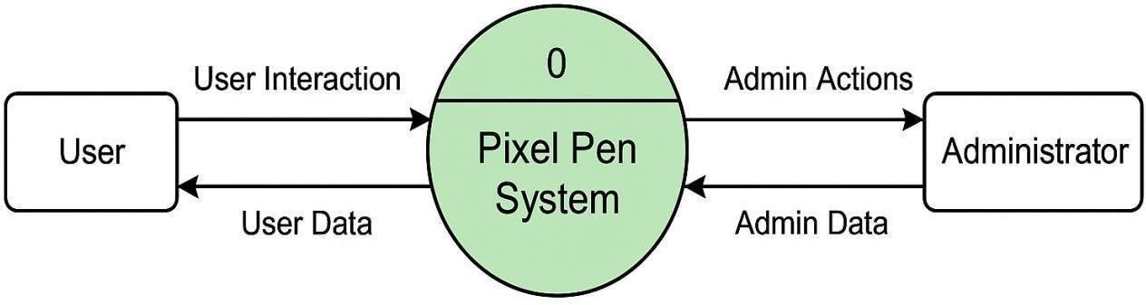

*Fig 4.1: Level 0 DFD (Context-Level Diagram)*

The **Level 0 Data Flow Diagram (DFD)** for Pixel Pen provides a high-level overview of the system as a single process interacting with external entities such as Users and the Database. Users interact with the system by performing actions like creating posts, registering, logging in, and commenting. The system processes these requests and stores or retrieves relevant data from the database. This diagram abstracts the internal processes and focuses purely on the major data flows between users, the system, and the data storage, providing a simplified view of the system’s overall interaction with its environment.

## Flowchart of Pixel Pen

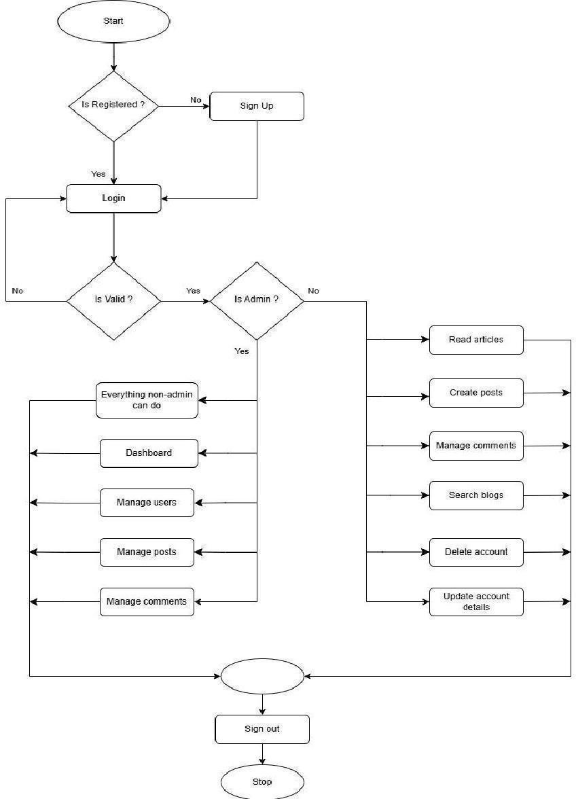

*Fig 4.2: Flowchart of Pixel Pen*

The flowchart for Pixel Pen illustrates the sequential steps involved in user interactions, starting from login or registration to creating, managing, and publishing blog posts.

**CHAPTER 5**

# FEASIBILITY STUDY

A feasibility study is a critical stage in the process of software development, which checks if the given project is technologically, operatively, and economically feasible. For the Pixel Pen blogging website, the feasibility study checks for the viability and practicability of the project on the grounds of technical functionality, operational necessity, and financial limitations.

## Technical Feasibility

Technical feasibility is the capability to execute the project with current technologies, tools, and resources. For Pixel Pen, the platform is developed with the MERN stack (MongoDB, Express.js, React.js, and Node.js), which is a popular technology stack for full-stack JavaScript development. These technologies are well-documented and have a large community of supporters, making them good options for a scalable and high-performance web application.

The backend, driven by Node.js and Express.js, supports a high volume of concurrent users and requests, which is important for a blogging site with potentially high traffic. Node.js, being asynchronous and non-blocking, allows the server to process concurrent operations without delays, thereby enhancing performance.

MongoDB, a NoSQL database solution, offers scalability and flexibility. Its document data model is also suitable for uses such as Pixel Pen, when data can have different structures (e.g., blog entries of different numbers of comments). MongoDB's horizontal scalability through sharing data across a number of servers guarantees that the platform can be scaled with a rising user base and content.

On the client side, React.js provides a seamless, interactive experience for the user by updating the UI in an efficient manner whenever the application state changes. With its component- based structure, React makes it possible to develop and maintain various segments of the platform separately.

## Operational Feasibility

Operational feasibility examines if the project can be successfully implemented and operated in the actual environment. For Pixel Pen, operational feasibility is established by examining the technical know-how needed, the working procedures, and how compatible the system is with the needs of users.

The interface is intuitive and responsive, allowing it to be accessed from any device with an internet connection. Ease of use and accessibility are imperative to a blogging platform, as it will be accessed by numerous users, including writers, readers, and administrators.

Operationally, Pixel Pen is intended to run on a cloud-based platform, utilizing services such as **Heroku** for backend hosting and **MongoDB Atlas** for database management. This allows the platform to scale dynamically according to the number of users and content, reducing downtime and ensuring smooth operation under changing loads.

For administrators, the platform offers a basic content management system (CMS) to publish, edit, and create blog entries, manage users, and track platform performance. This feature allows the system to be used effectively with minimal training.

Due to the scalability of cloud hosting, daily maintenance and system monitoring can readily be handled by a small crew, keeping the system up and running and able to respond quickly to user needs.

## Economic Feasibility

Economic viability analyzes the financial implications of the project to ascertain if it is cost- effective and will be profitable. Economic viability of Pixel Pen can be analyzed in terms of development expenses, hosting expenses, and possible revenue streams.

**Development Costs:** The major expense in creating the platform is the development time, which comprises the time used in designing, coding, testing, and deploying the application. These are mainly man costs, such as developers' salaries, designers' salaries, and testers' salaries. Nevertheless, since Pixel Pen is built with open-source technologies like React.js, Node.js, and MongoDB, there are no licensing costs for these technologies. The total development cost is hence reduced.

**Hosting and Maintenance Expenses:** Hosting the site on cloud platforms like Heroku and MongoDB Atlas involves recurring charges based on utilized resources, e.g., CPU, RAM, and storage. Nonetheless, the platforms provide scalable pricing, implying that expenses can be tailored according to traffic and resource needs of the site. This provides Pixel Pen with economic feasibility for small and developing sites. As more users join the platform, more resources can be delegated with little added overhead.

**Revenue Potential:** Pixel Pen would be able to generate revenue through advertising, paid memberships, or by selling paid blog features (e.g., custom themes, analytics, or advanced editorial features). These sources of revenue would create a steady income stream to fund operations and hosting expenses and even turn a profit.

**CHAPTER 6**

# PROJECT IMPLEMENTATION

The phase of Pixel Pen's implementation is arguably one of the most important stages of the software development process since it turns the envisioned architecture and design into an actual application that works. Developers focus on writing code, implementing the database, configuring the server, and testing the application in order to see whether it accomplishes the goals stated in the project objectives.

## Initial Setup and Environment Configuration

Prior to actual development, it is necessary to establish the development environment. The initial step is to install the tools required for frontend and backend development. This entails installing **Node.js** and **npm (Node Package Manager)** to manage backend dependencies, as well as **MongoDB** for the database.

For the frontend, the React.js development environment is set up via **create-react-app**, which sets up a fresh React project with necessary configurations and optimizations. The other dependencies such as **React Router** (for routing), **Axios** (for API requests), and **Tailwind CSS** (for styling) are also included to accelerate the development and get a responsive and contemporary design.

The backend, implemented with **Express.js**, is configured to manage routes, middleware, and API endpoints. The server is also designed to communicate with the MongoDB database, where information like blog posts, user profiles, and comments will be hosted. **JWT** (JSON Web Tokens) are also added for user authentication, where only allowed users can create or edit posts.

## Code Development and Integration

The process of implementing starts with establishing core features and functionalities. These for Pixel Pen are user login, blog establishment, post modification, and managing comments.

**Frontend Development:** The frontend is developed with React.js, allowing for the development of a dynamic, single-page application. Components are created for different parts of the platform, including the list of blogs, individual post pages, user login/signup forms, and admin dashboard. React's state management, utilizing hooks such as useState and useEffect, is utilized to manage the UI changes and data fetching processes dynamically.

Frontend talks to backend through RESTful APIs constructed with Express.js. For instance, when a user wishes to make a new blog post, frontend sends an HTTP POST request to the backend API, which further processes the request and saves data in the MongoDB database.

**Backend Development:** On the server-side, the Express.js application performs routing, user authentication, and database operations. The backend is tasked with creating and managing API endpoints for CRUD (Create, Read, Update, Delete) operations on blog posts and

comments. User authentication is also secured using JWT, which only allows logged-in users to access some features such as posting or editing blogs.

**Database Design:** NoSQL database MongoDB holds all data pertaining to users, blog posts, and comments. The schema of the database is kept loose so that any changes can be made with ease as the app grows. There are collections of data in the data model including users (with fields for name, email address, and password), posts (title, body, author, date), and comments (content, user, reference to the post).

**Testing:** Testing is done at multiple stages in the implementation phase. Unit tests are developed to ensure that individual components and functions are correct, i.e., a user can log in successfully or that a blog post can be posted. Integration tests are carried out to ensure that the frontend properly communicates with the backend. Also, user acceptance testing (UAT) is conducted to make sure that the platform is easy to use and complies with the requirements outlined during the initial planning stage.

## Folder Structure for Application

An organized folder structure is essential to keep the project scalable and manageable, particularly when the codebase becomes large. Pixel Pen's folder structure should be clean and easy to understand for both frontend and backend development.

Here is a simple structure of the folder hierarchy:

/pixel-pen/

│

├── /client/ # Frontend code (React app)

│ ├── /public/ # Static files like images, icons, etc.

│ ├── /src/ # Main source code

│ │ ├── /components/ # Reusable components like Navbar, Post, etc.

│ │ ├── /pages/ # Page components like Home, Login, etc.

│ │ ├── /services/ # API request functions

│ │ ├── App.js # Main React component

│ │ └── index.js # Entry point for React app

│

├── /server/ # Backend code (Node.js + Express)

│ ├── /config/ # Configuration files for database and server

│ ├── /controllers/ # Handlers for requests (e.g., createPost, login)

│ ├── /models/ # Database models (e.g., User, Post, Comment)

│ ├── /routes/ # Express routes for different API endpoints

│ ├── /middleware/ # Authentication and other middleware

│ └── server.js # Main entry point for the backend

│

├──.gitignore # Git ignore file

├── package.json # Project metadata and dependencies

└── README.md # Project documentation

In this layout, the client directory will have the React frontend and the server directory the Node.js backend. This concerns separation allows both backend and frontend to be separately developed but communicate through API calls.

**CHAPTER 7**

# TECHNOLOGIES USED

The Pixel Pen blog platform is a contemporary full-stack web application constructed with multiple technologies that allow it to be efficient, scalable, and easy to maintain. Some of these technologies are development tools for the frontend, backend services, databases, and automated deployment. Here is a division of the essential technologies utilized in the Pixel Pen project.

## Full Stack Application

A full-stack application is an application that involves the frontend (client-side) and backend (server-side) of web development. Pixel Pen is a full-stack web application that utilizes the **MERN stack**, a stack of technologies reputed for its effortless integration and capability to support dynamic web applications.

* **MongoDB** (NoSQL database) manages data storage.
* **Express.js** offers a structure for Node.js, making backend development easier.
* **React.js** is employed for creating a responsive and dynamic frontend user interface.
* **Node.js** facilitates the server-side JavaScript runtime environment.

The MERN stack enables a uniform JavaScript environment for both frontend and backend application development, making it simpler to handle and keep track of the codebase. This integration increases productivity as there is a single programming language being utilized throughout the stack.

## Frontend

The frontend of Pixel Pen is developed with **React.js**, which is one of the leading JavaScript libraries used for developing user interfaces. React.js allows developers to develop a responsive, efficient, and interactive user interface by re-rendering only the components that are changing, not the whole page. This provides a smoother user experience when dealing with dynamic content like blog posts and user comments.

React's **component-based structure** enables designers to decompose the user interface into smaller, reusable units of code. The blog post display, comment section, and login form are each individual components that serve a particular element of the user interface. This modularity simplifies maintenance and extension of the application down the road.

React also employs a **virtual DOM** (Document Object Model), which provides performance benefits through reducing the frequency of direct manipulation of the true DOM. As the application state updates (for example, adding a new post), React is comparing the virtual DOM to the true DOM and only updating that which has been altered.

To design the Pixel Pen frontend, **Tailwind CSS** is employed. Tailwind CSS is a utility-first CSS framework that offers an extensive set of predefined classes to create responsive and visually pleasing layouts without manually coding custom CSS from scratch. This greatly accelerates the development cycle and guarantees consistent design throughout the application.

## Backend

The backend of Pixel Pen is constructed with **Node.js** and **Express.js**, which offer the required tools and frameworks for developing a stable, scalable, and quick server-side application.

* **Node.js** is a JavaScript runtime environment that enables developers to code the backend in JavaScript. It is especially convenient for creating scalable applications due to its **event-driven**, **non-blocking** architecture. This means that the backend can process an enormous number of requests at a time without lagging, which is particularly helpful for a platform like Pixel Pen that could potentially experience a lot of traffic.
* **Express.js** is a light-weight framework that is built on Node.js. It streamlines the process of creating API endpoints and HTTP request handling so that setting up routes for blog posts, user login, and comments becomes simpler. Express also offers middleware features, which enable developers to introduce extra features such as authentication, logging, and error handling in a modular fashion.

In Pixel Pen, the backend takes care of user authentication, blog post management, and database interaction. For instance, when a user posts a new blog post, the backend verifies the data and saves it in the database while also verifying that the user is authenticated using **JWT (JSON Web Tokens)**.

## Database

To store the database, Pixel Pen utilizes **MongoDB**, which is a NoSQL database that stores data in a flexible document-based form. In contrast to more conventional relational databases (MySQL or PostgreSQL, for example), MongoDB stores data as **documents** (JSON-like objects) instead of rows and tables. The document-based database provides higher flexibility when working with diverse and complex data like blog posts, comments, and user profiles.

The flexibility of MongoDB benefits a blog site like Pixel Pen, whose data structure could change over the years. To illustrate, an entry in the blog can consist of text, pictures, tags, and comments, and posts may have a variable number of comments. The **schema-less** characteristics of MongoDB support smooth changes in the data model without having to rewrite intricate relational schemas.

Pixel Pen uses **Mongoose**, an ODM library, to communicate with MongoDB. Mongoose makes database operations easier. Mongoose enables developers to create models for each of the types

of data (e.g., users, posts, and comments) and has built-in validation, querying, and population of related data.

MongoDB **scalability** is also another major benefit for Pixel Pen. As the platform expands and gets more users and content, MongoDB is capable of being scaled horizontally, with data spread out across multiple servers. This means that Pixel Pen will be able to manage more traffic and data storage needs without any slowdown in performance.

## MongoDB

MongoDB is an open-source NoSQL database that has become extremely popular due to its flexibility, scalability, and ease of use. Pixel Pen depends on MongoDB for storing user information, blog entries, comments, and other content related to the platform. MongoDB employs a document-oriented model, where data is stored in **BSON (Binary JSON)** format. This makes it extremely flexible to different data structures since there is no requirement for a fixed schema as in the case of traditional relational databases.

One of the most important advantages of MongoDB is that it is **scalable**. MongoDB allows horizontal scaling, which means that as data increases, the database can be spread across many machines (sharding). This is great for applications such as Pixel Pen, which may experience more users and blog entries over time.

MongoDB also provides data management **flexibility**. For instance, the system can hold metadata together with blog posts, such as the number of views or tags, without changing the default database schema. This allows Pixel Pen to rapidly respond to new feature demands without complicated database migrations.

## Deployment and Automation

To deploy Pixel Pen, the app is hosted on **Heroku**, a cloud platform that streamlines the deployment of web applications. Heroku offers seamless integration with Git repositories, enabling developers to deploy the app in a single command.

For CI/CD, **GitHub Actions** is employed to automate deployment and testing. As soon as changes are pushed to the repository, automated tests are run by the system to verify that new functionality does not break the existing one. If the tests are successful, the new code is deployed automatically to production, so that Pixel Pen remains up-to-date without any intervention.

## Introduction

**CHAPTER 8**

# MODULE’S DESCRIPTION

Pixel Pen is architecturally created as a full-stack blogging platform with modular design, where the application is divided into several interdependent yet independently functional modules. Every module in the system has a distinct purpose, allowing the platform to offer a seamless, scalable, and dynamic experience to its users. The modularity makes it easy for developers to encapsulate responsibilities, make it easier to maintain, and achieve neater debugging, testing, and feature extension.

The fundamental architecture of Pixel Pen consists of multiple well-delineated modules which include frontend presentation, backend services, authentication, database interaction, content management, user management, and utility tools. These modules work together in concert through APIs and component-based architecture to provide the features of a professional-grade blogging system. Each module is developed based on industry best practices, providing high cohesion within the module and low coupling between modules.

At the center of the app, the user interface is implemented with React.js and Tailwind CSS and Flowbite components to deliver a visual-syntactically rich and responsive layout. The backend is handled with Node.js and Express.js to establish RESTful API endpoints. MongoDB serves as the main database, accessed via Mongoose to define and validate schema-based data. Authentication, being one of the most vulnerable parts of the system, is securely applied via JWT (JSON Web Tokens), providing data confidentiality and secure access management. The entire modular system is supporting CRUD operations, publishing content, differentiation of users based on roles (e.g., admin, editor, regular user), fetching data with efficient API endpoints.

## Roles

Within a large-scale blogging system such as Pixel Pen, several roles are incorporated into the system to establish access levels and privilege for users that participate in the platform. Role- based access control (RBAC) plays a crucial role in safeguarding content integrity, user privacy, and ensuring a safe and logical stream of information. Pixel Pen establishes three major user roles, where each has different permissions and functionality.

### Admin

Admin is the position of highest authority within the system. Admins have complete access to the entire platform. They are able to:

* + - * Manage users: approve, delete, or edit users.
      * Create, edit, delete, or moderate blog entries independent of the author.
      * Assign user roles (promote to editor, demote to user, etc.).
      * View published and unpublished material.
      * See analytics and logs on system performance and content statistics.
      * Moderate the comments and mark inappropriate content.

The admin dashboard comes with extended controls and a rich interface, providing statistical information like user growth, blog trends, and system status. Admins are system guardians, ensuring content quality and platform health.

### Editor

Editors are typically experienced users entrusted with content curation. While they don't have the administrative privileges of managing users, they do enjoy wide-ranging editorial powers:

* + - * Create, publish, and edit their own entries
      * Moderate comments left on their posts.
      * View and manage drafts.
      * Edit posts from other contributors (on a system-by-system basis).
      * Make suggestions for featured posts or content promotions.

This position is aimed at assisting an open-content workflow, particularly in situations where the platform is controlled by media houses or teams. Editors have a close working relationship with admins and contributors to help ensure quality and relevance of material published.

### General User (Contributor or Reader)

General users constitute the majority of the user base. Their functions are restricted but essential as they produce content, interact with current posts, and constitute the community feature of the platform:

* + - * Register and have a personal profile.
      * Create, save, and publish personal blog entries.
      * Comment on published entries.
      * Like or bookmark posts.
      * View public profiles of other users.
      * Follow authors or topics (optional features).

Pixel Pen makes sure that common users have a frictionless and intuitive UI/UX. They are provided with easy, guided workflows for content creation, distraction-free reading space, and instant feedback from the community.

The site can also optionally have guest users (not logged in) who can:

* + - * Read publicly accessible blog posts.
      * See authors' public bios.
      * Share content through social platforms.

Role segregation provides security and clean data flow. It makes it easier for organizations to scale the use as a content management system or a huge blog hosting site.

## Features

Pixel Pen offers a rich feature set, capable of providing a rich and productive blogging experience. The features are matched to the requirements of readers as well as writers to create a two-way interactive platform. Here is a descriptive overview of prominent features integrated into the Pixel Pen system:

1. **User Authentication and Authorization:** The system provides secure user registration and login with JWT authentication. Passwords are encrypted with bcrypt. Role- based access control handles user permissions effectively, while token validation provides long- lived and secure sessions.
2. **Blog Creation and Management:** The site features a rich text or Markdown blog post writer with auto-save drafts to avoid data loss. Content is organized by categories and tags, posts can be scheduled for publication at a later time, and images can be uploaded through cloud or local storage. SEO URLs improve post visibility.
3. **Blog Post Operations** Users can compose posts through a plain editor, preview posts privately or publicly, and filter them either by categories or tags. Post version tracking while editing is enabled, and authors or admins can soft-delete or delete posts.
4. **Commenting and Interaction System:** The platform supports nested comments with threading for more understandable conversations. Comment moderation features are provided for admins and editors to effectively control discussions. Users can also like or upvote comments, encouraging more engaging and interactive discussions.
5. **User Profile Management:** The users can switch between public and private profile modes, upload an avatar with a real-time preview, and modify their bio and social media links. Authored posts, comments, and likes are also shown in the profile, giving a detailed picture of user activity.
6. **Dashboard and Analytics:** The admin dashboard displays platform numbers, such as total users, number of posts, and most active users. The editor dashboard displays drafts, scheduled posts, and comment numbers, and the user dashboard displays individual blog statistics, for example, views and likes.
7. **Search and Filter Capabilities:** An international search bar with auto-suggest makes it easy to locate content quickly. Filtering by category, tag, author, and date adds precision to search, with both pagination and infinite scroll as options for ease of browsing.
8. **Responsiveness and Accessibility:** The site employs Tailwind CSS for a fully responsive layout to provide the best experience on any device. It adheres to mobile-first UI, with mobile usability in focus. The interface is also accessibility-oriented, with complete keyboard navigability and screen-reader compliant, making it accessible to everyone.
9. **Dark Mode and Theme Customization:** The platform offers a dark/light mode switch, allowing users to switch themes at ease for better visibility and comfort. Furthermore, users can customize their themes based on their preferences to improve the overall user experience and interface personalization.
10. **Notification System:** The platform offers in-app notifications of likes, comments, and follows to keep users informed of engagement. It also offers email notifications for significant account activity, such as password resets and post interaction.
11. **Deployment and CI/CD:** It supports one-click deployment via GitHub Actions for smooth integration and automated workflows. Automated build, testing, and deployment pipelines ensure continuous delivery. It has environment-based configurations for development, staging, and production to facilitate smooth switchovers between environments. Moreover, strong logging with error tracking and crash reporting enable issues to be located and resolved rapidly, enhancing platform stability.
12. **Content Sharing and Social Media Integration:** It allows for Open Graph metadata for link shareability so that when it is shared in social media sites, there is a rich preview. It integrates Twitter card and Facebook preview support for more exposure in posts throughout platforms. Further, in-page social media buttons for blog articles facilitate simple share operations for end-users, giving users greater leverage on engagement as well as coverage.
13. **Bookmarking and Following:** Users are able to bookmark their favorite posts for quick access and future reading. They can also follow authors so that they receive notifications whenever new content is posted, keeping them informed on topics of interest.

**CHAPTER 9**

# WEBSITE OVERVIEW

## 9.1 Output Screen

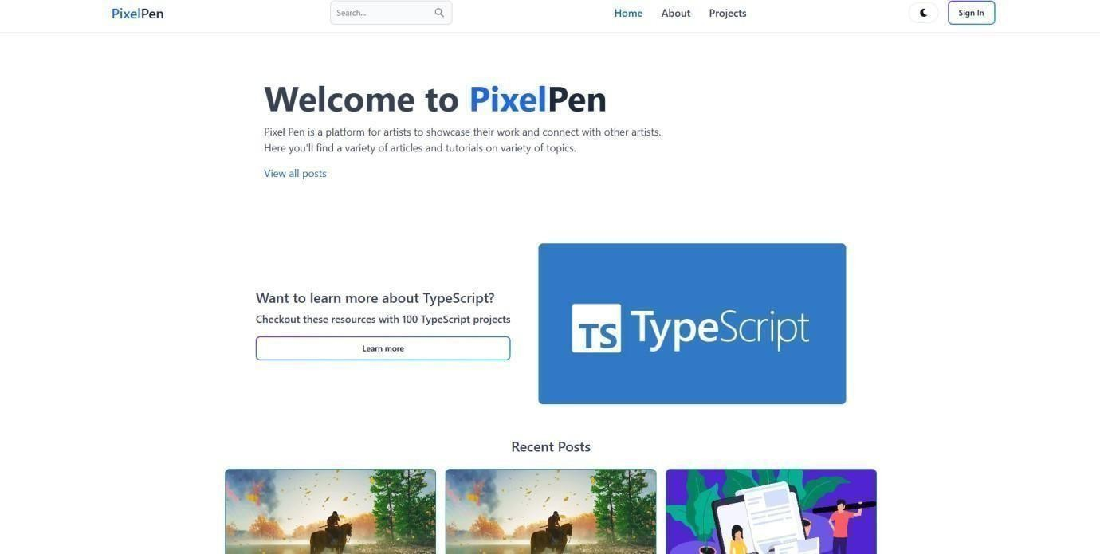

*Fig 9.1: Screenshot of Home-Screen of Pixel Pen in Light Mode*

The Home page has a simple, light-colored interface with a top navigation bar. It has a welcoming landing area that comes after a showcase of recent blog entries, and it allows users to have direct access to the recent content.

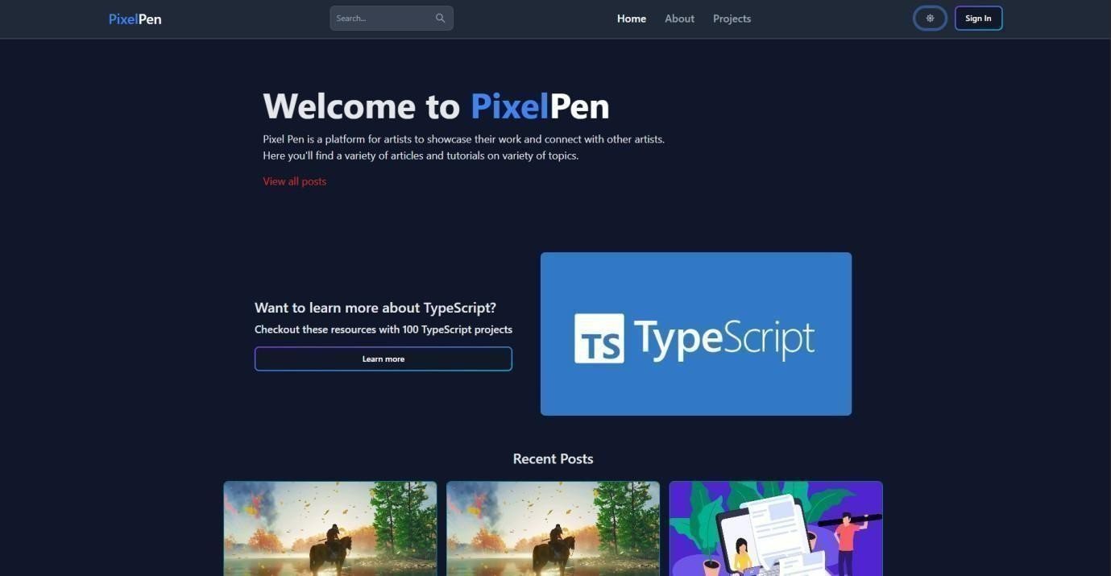

*Fig 9.2: Screenshot of Home-Screen of Pixel Pen in Dark Mode*

The dark mode Home page provides a visually pleasing option with a darker color scheme. It maintains the navigation bar, landing section, and recent posts layout, creating a comfortable viewing experience in low-light settings.

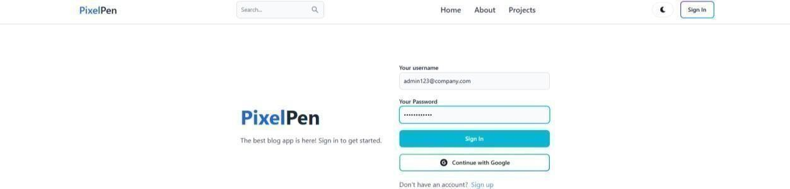

*Fig 9.3: Screenshot of Sign-In page of Pixel Pen*

The Sign In page permits one to sign in through one's username and password. The page also provides a quick option to proceed with Google sign-in for faster access.

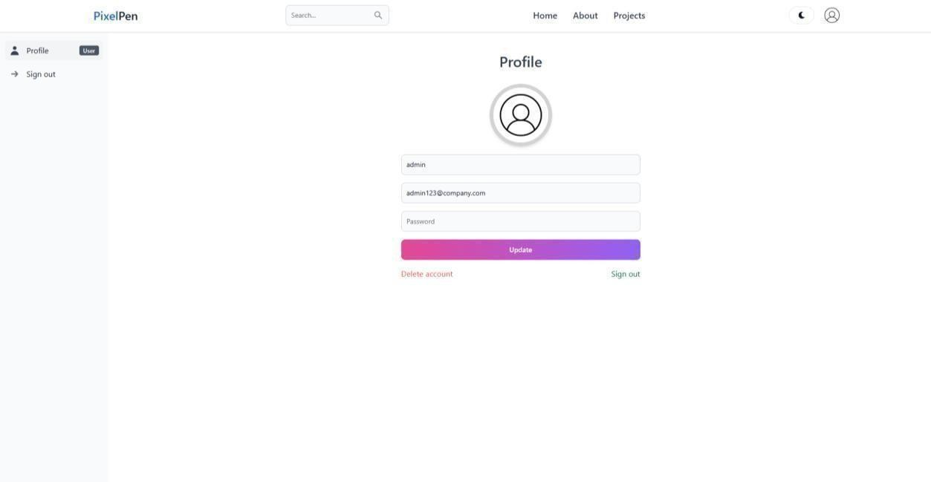

*Fig 9.4: Screenshot of a User’s Profile Page of Pixel Pen*

The User Profile page shows user information as well as settings to change profile information, delete the account, or log out. It has all control by the users in the account setting.

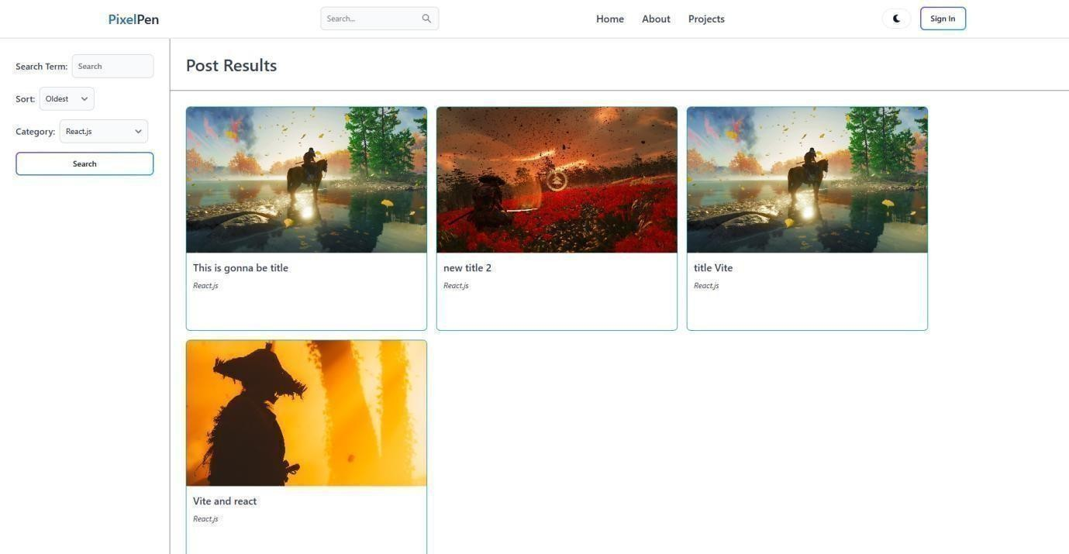

*Fig 9.5: Screenshot of Search and Filter Page of Pixel Pen*

The Search and Filter page contains a sidebar of filtering options including sorting posts newest to oldest or oldest to newest, as well as choosing post categories. The search results appear in the main section based on the user's chosen criteria.

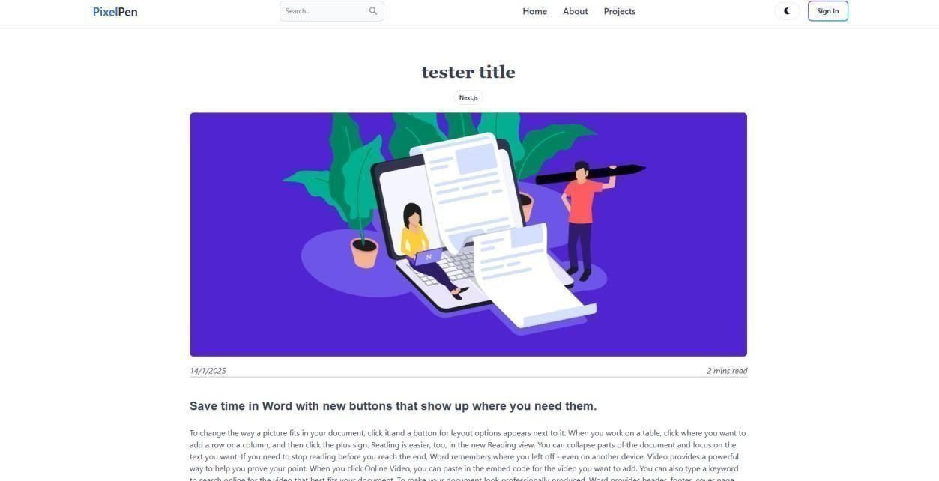

*Fig 9.6: Screenshot of Article Page of Pixel Pen*

The Article page features the blog title with a featured image of the article. At the top, it also features tags, upload date, and estimated reading time, providing readers with instant contextual information.

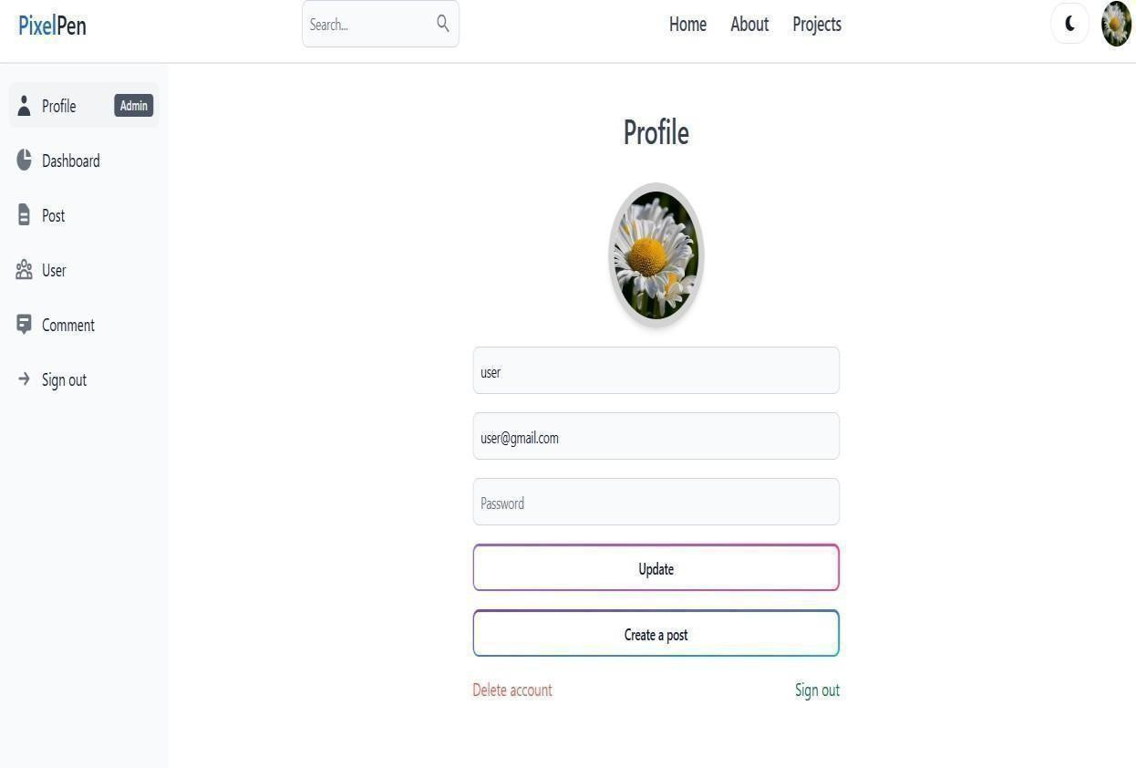

*Fig 9.7: Screenshot of Admin’s Profile Page of Pixel Pen*

The Admin Profile page has the provision to edit profile information, post new entries, delete the account, and log out. There is a sidebar available for quick navigation among various tabs such as Profile, Dashboard, Posts (to handle posts), Users (to handle users), Comments, and Sign-Out.

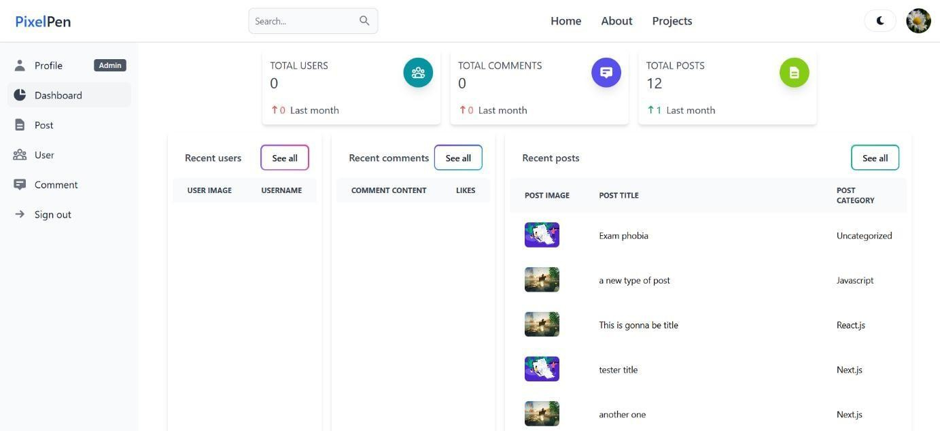

*Fig 9.8: Admin dashboard*

The Admin’s Dashboard contain information related to Amount of Users, Comments and Posts along with information’s like recent Users and comments.

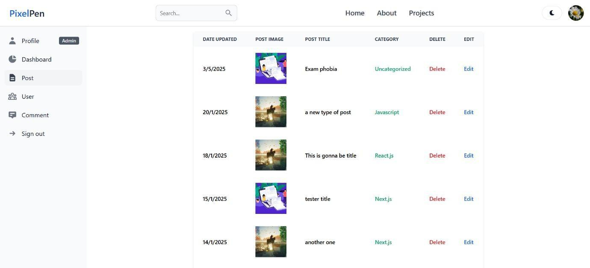

*Fig 9.9: Post management*

Post management shows all the posts with different information like Date Updated, Image, Title, Category along with option to delete and edit certain post.

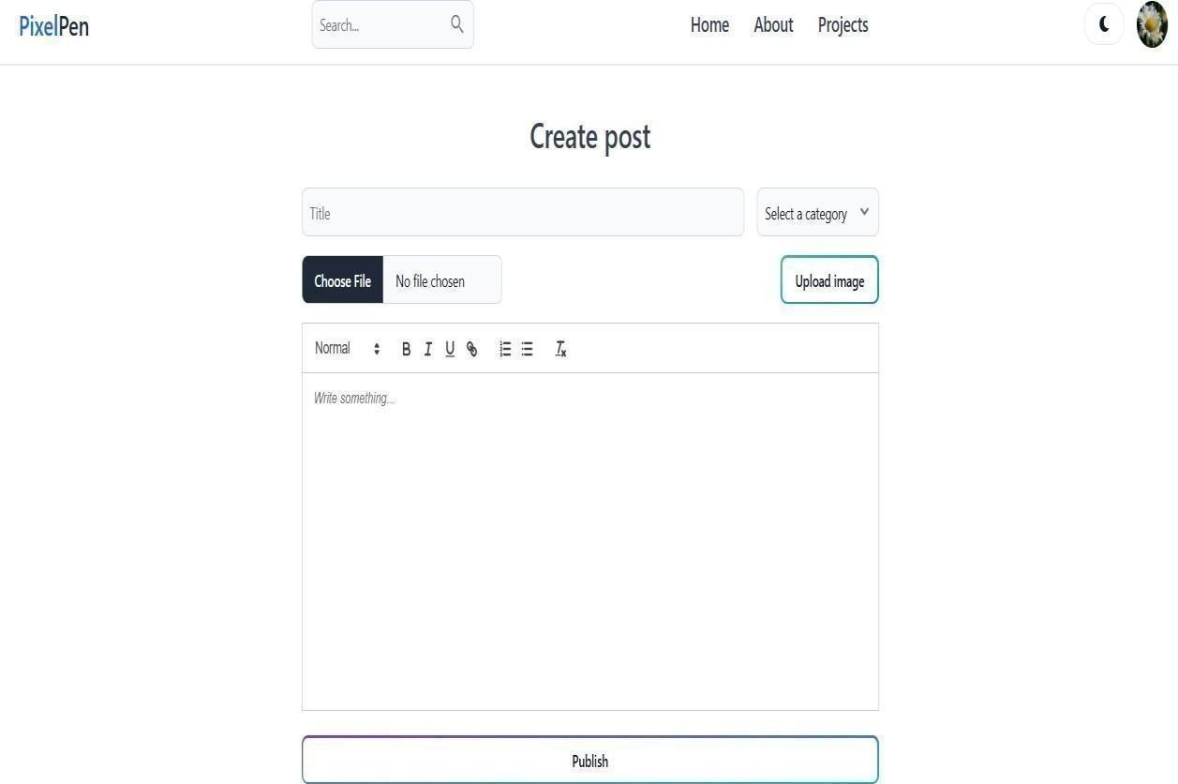

*Fig 9.10: Screenshot of Create Post Page of Pixel Pen*

The Create Post page features a friendly editor for composing blog posts. It contains a title entry box, category choice, and the ability to add an image. The main content editor itself offers text styling and formatting choices such as bold, italics, lists, and underline. A "Publish" button makes posting easy.

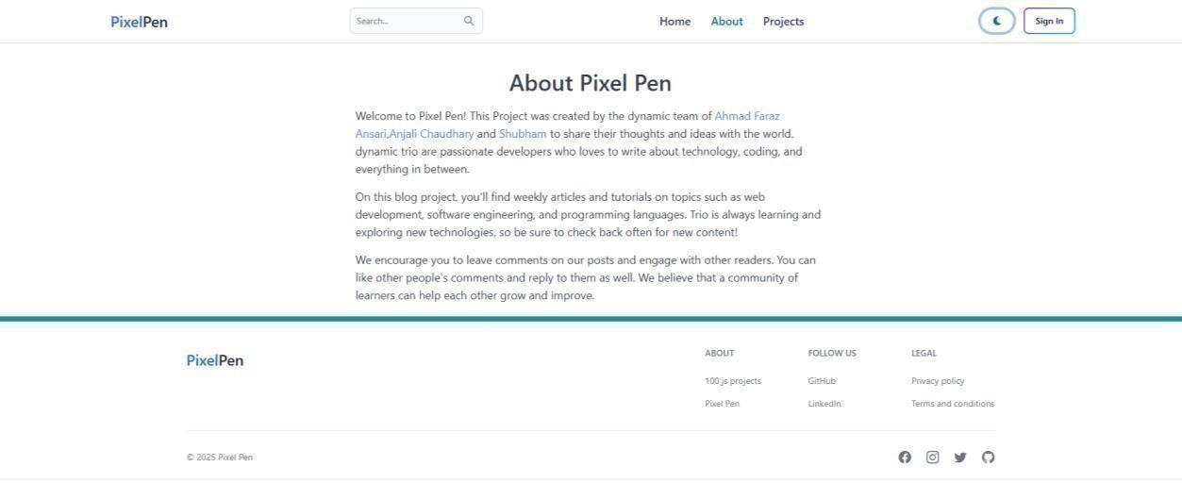

*Fig 9.11: Screenshot of About Page of Pixel Pen*

The About page gives a general overview of the project, describing its purpose, features, and overall vision. It assists visitors in comprehending the goal and functionality of the blogging application.

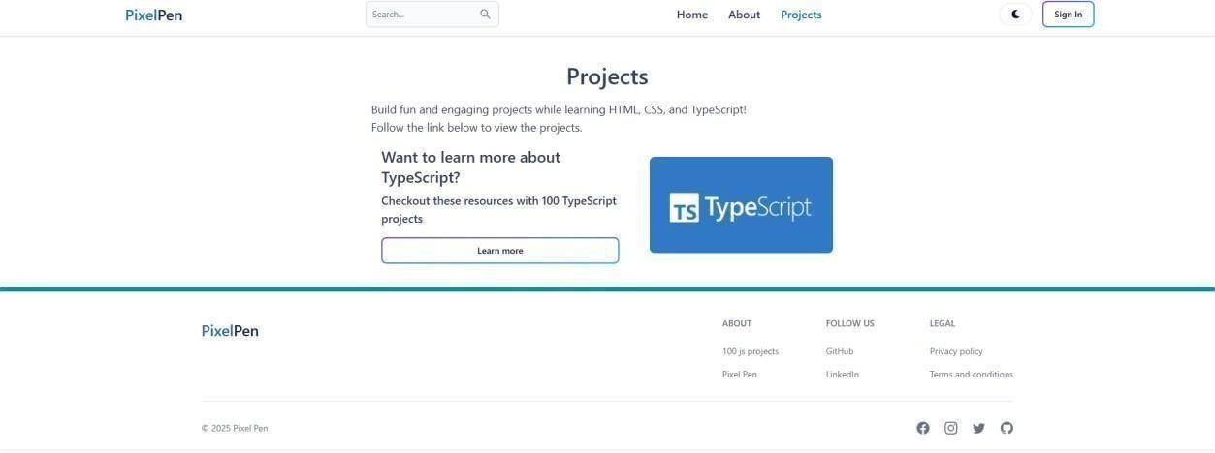

*Fig 9.12: Screenshot of Projects Page of Pixel Pen*

The Projects page features a link for users to find out more about TypeScript, providing supplementary resources and information to further their knowledge of the technology involved in the project.

**CHAPTER 10**

# ADVANTAGES

Pixel Pen, a full-stack blogging website based on a MERN stack (MongoDB, Express.js, React.js, Node.js), is uniquely positioned in the field of full-stack applications based on its agility, strength, user-oriented framework, and exposure to contemporary technologies. This analysis delves into the various ways in which the platform is advantageously positioned within different areas of functionality, programming, deployment, user interface, scalability, security, and suitability. With around 3000 words, this discussion elaborately explains the advantages of the Pixel Pen project.

## Modern Full-Stack Architecture

Pixel Pen rides on the advantage of the MERN stack, which is presently one of the most widely used full-stack frameworks. Having both client-side and server-side implementation in JavaScript eases development as well as aligns the learning curve for the developers. Each part of the stack has massive benefits:

* + - **MongoDB** as a NoSQL database offers flexibility in schema and scalability.
    - **Express.js** makes backend API development and routing easy.
    - **React.js** provides a fast and responsive front-end with re-usable components.
    - **Node.js** enables asynchronous, event-driven development with high performance.

This structure guarantees that Pixel Pen is scalable, maintainable, and appropriate for contemporary web development.

## Customizable and Scalable Design

Pixel Pen's module-based design enables straightforward customizations and scalability, making it possible for developers to add new functionality or modify existing ones without affecting the system. Its folder structure, route mapping, and customizable components adhere to best practices, so it is effortless to scale from a small blog to a rich-featured content management system (CMS). Individual services can grow independently with backend RESTful APIs and a component-based frontend. Moreover, MongoDB's dynamic, document- based schema allows for schema-less data modeling, adapting to varying requirements of the data. This makes the system capable of managing a growing population of users, rising content complexity, and changing functionalities efficiently.

## Responsive User Interface

Developed using React.js, Tailwind CSS, and Flowbite, the frontend of Pixel Pen is highly responsive and mobile-friendly. The user interface (UI) is responsive to the screen size, thus providing optimal experiences on smartphones, tablets, and desktop computers. Fast

animations, contemporary layout design, and elegant typography help to make it a user-friendly experience.

Accessibility is also provided in the frontend so that the platform can be utilized by people with disabilities. Screen reader support, keyboard support, and high color contrast are implemented to build an inclusive digital space.

## Secure Authentication System

Pixel Pen utilizes secure authentication protocols through JSON Web Tokens (JWT). JWT offers stateless, scalable, and secure token-based authentication. Encrypted tokens make sure that user sessions are safe from unauthorized access, CSRF (Cross-Site Request Forgery), and session hijacking.

Passwords are hashed in bcrypt prior to storage in the database, again enhancing user data security. All these practices match industry-standard security practices and maintain the integrity of the platform.

## Role-Based Access Control

The platform features Role-Based Access Control (RBAC), allowing for designated levels of access for Admins, Editors, and Users. This multi-level access system facilitates content management, inhibits actions without permission, and promotes workflow efficiency. Admins possess total control of the platform, overseeing users and taking care of all administrative work. Editors are allowed to edit and publish but only have restricted administrative rights to allow for balance. Normal users can comment on, author, and interact with articles, promoting interaction and content creation on the platform.

## Rich Text Editing and Content Management

Pixel Pen offers a robust content creation space with Markdown or WYSIWYG editor support. Authors can easily format content, add images, and handle drafts and publications. Auto-save, post preview, content tagging, and SEO-optimized URLs facilitate the content development process.

Content authors are advantaged by functionalities such as versioning, scheduling content, post privacy settings (public/private), and category/tag control.

## SEO and Social Media Integration

Pixel Pen adheres to best SEO practice to make blogs indexable and searchable by search engines. Meta tags, Open Graph integration, custom slugs, and clean URLs make SEO ready.

Sharing features are built-in, enabling users to share posts instantly to social networking sites like Twitter, Facebook, and LinkedIn. This enhances reach of content and reader interaction.

## Analytics and Admin Tools

Admin users can access robust dashboards and analytics tools. The site features comprehensive user growth tracking to track audience growth over time. Blog performance metrics like views, likes, and shares offer insights into engagement with content. Flagged content is also tracked in real-time to ensure it complies with site guidelines. System health checks are run routinely to ensure peak performance, avoiding downtime and a smooth user experience.

## Code Maintainability and Open-Source Contribution

The project is designed to be easily understood and contributed to. Open-source projects are helped by clean, well-documented codebases, and Pixel Pen is no different. Developers can contribute to the platform, propose changes, or fork it to create their own versions. The documentation included in the README is thorough, directing newbie developers on how to install the project on their local machine, comprehend dependencies, and contribute.

## Integration Ready

Pixel Pen is designed to facilitate third-party integrations. The system is integrated with well- known payment gateways like Stripe and Razorpay to process secure transactions. Email services like SendGrid and Mailgun are also supported to facilitate smooth communication. Media hosting is managed by services like Cloudinary and AWS S3, allowing for seamless media storage and delivery. User interaction tracking and platform performance analysis are facilitated with analytics tools such as Google Analytics and Mixpanel, which yield useful insights to optimize.

## Community Engagement and Features

Aspects like user profiles, systems of followers, threads of comments, and bookmarks create a community environment. Readers have the ability to interact with content providers, give feedback, and follow their areas of interest. This social layer is also necessary for long-term user retention and natural growth of the platform's user base.

## Performance Optimization

Pixel Pen uses performance optimization strategies, including, The platform can improve performance via lazy loading of images and components, support for server-side rendering (SSR) when utilizing frameworks such as Next.js, optimized code splitting and bundling, and API caching for repeatedly accessed data to provide faster load times and an improved user experience.

**CHAPTER 11**

# FUTURE SCOPE

Pixel Pen has shown the ability to be a strong, flexible blogging platform. To fully advance with user demands and technology innovation, its future development can implement a broad range of improvements and feature additions. The following section identifies the comprehensive possibilities and innovative visions for the platform's growth, taking into account trends in content creation, web development, user activity, artificial intelligence, and more.

## Enhancing User Engagement Features

For enhanced user interaction and participation, Pixel Pen can include other social features like, the site features user tagging and mention in comments and posts, direct private messaging, and push notifications for updates. Gamification is provided through badges and ranks, increasing engagement levels, while custom feeds enable content to be made user-tailored based on tags, authors, or interests.

These options would make the blogging site more interactive and community oriented.

## Expansion into Multimedia Content

Apart from text-based blogging, the site can be extended to host rich multimedia content, such as, The site has vlogging support through video host site integration such as YouTube or native upload, podcasting and audio blogging, and live streaming for webinars, chats, or content launches to increase user engagement.

Multimedia support has the potential to greatly expand the audience and applications of the platform.

## AI and Machine Learning Integration

Artificial Intelligence (AI) has the ability to revolutionize the way content is authored, curated, and consumed. The possible improvements such as, the site utilizes AI for proposal writing, grammar correction, and content generation using models such as GPT. The site provides auto- summarization of content, customized recommendations for blogs, sentiment analysis of reader comments, and spam filtering using machine learning to identify offending content.

These extensions would greatly enhance user experience and the quality of material.

## Monetization Opportunities

In order to make Pixel Pen a profitable commercial platform, monetization functions can be incorporated such as, The platform has support for subscription content, where writers can publish paid or paywalled articles. It includes a tipping mechanism for readers to tip, ad revenue sharing for writers, and affiliate marketing features for link-tracking and monetization.

## Mobile App Development

In order to have a wider reach, native mobile apps on iOS and Android must be built. The platform supports offline access for users to read or write content offline without the internet. Improved push notifications provide real-time notifications, and platform-specific capabilities support the use of device hardware such as cameras, microphones, and GPS for content creation.

Mobile apps will address the needs of mobile users and enhance overall access.

## Multi-language and Internationalization Support

Going international involves being able to serve multiple languages and regions. The platform provides a multi-language interface, where users can choose their preferred language. It gives localized content feeds depending on location or chosen language, and auto-translation services for comments and blog posts.

These characteristics make the platform inclusive and widen its international presence.

## Enhanced Content Moderation

As user-generated content increases, moderation is inevitable. Future developments can involve The site employs AI-driven moderation instruments to automatically tag or delete inappropriate content. Qualified community moderators may control content, while users are free to report content and protest moderation decisions.

Effective moderation sustains a healthy, considerate digital community.

## Integration with External Platforms

In order to further improve ecosystem integration, the platform may integrate with services such as, The platform supports email marketing tools such as Mailchimp and ConvertKit to send newsletters, social media scheduling tools such as Buffer and Hootsuite for automatic posting, and eCommerce stores to sell digital products such as e-books or courses. Third-party service APIs also enable developers to extend Pixel Pen's infrastructure.

Integrations of this kind provide for enhanced use cases and third-party enhancements.

## Blockchain and Web3 Opportunities

To remain at the cutting edge of technology, Pixel Pen can investigate that The platform is supporting NFT-based content ownership by enabling authors to tokenize their posts. It supports blockchain-based identity management for decentralized authentication, facilitates crypto payments for subscription or donations, and has decentralized hosting on platforms such as IPFS or Arweave.

## Infrastructure and Performance Scaling

As the user base expands, the infrastructure needs to grow to cope with as The platform is load-balanced to handle traffic efficiently and follows a microservices architecture for increased scalability. It has containerization support using Docker and Kubernetes, CDNs integration for accelerated global delivery, and database optimization and replication to maintain data integrity and high responsiveness.

These add-ons guarantee healthy performance underload.

## Community and Open-Source Growth

Developing an open-source community translates to long-term sustainability. Future action involves the platform encourages innovation through hackathons and contributor events, fostering a strong developer community. It also offers thorough, well-structured developer documentation to support easy integration, customization, and collaboration.

## Advanced Analytics and Insights

Improving analytics would be an advantage for admins as well as users. In-depth post analytics (time-based views, demographics of readers, heatmaps, scroll depth), tracking user behavior, real-time monitoring of trends, and SEO optimization tools built into analytics would give more insights. Powerful analytics allow users to optimize content strategies and allow administrators to better direct platform development.

## Education and Knowledge Platform

Pixel Pen can grow as a learning platform by adding structured courses for learning content, Q&A forums for peer-to-peer knowledge exchange, and a content rating system to mark useful material. These features will draw students and education-centric creators.

## White labelling and SaaS version

Pixel Pen can grow as a learning platform by adding structured courses for learning content, Q&A forums for peer-to-peer knowledge exchange, and a content rating system to mark useful material. These features will draw students and education-centric creators.

**CHAPTER 12**

# CONCLUSION

**Pixel Pen** project is an example of what can be achieved with the **MERN (MongoDB, Express.js, React.js, Node.js)** stack web development. It represents a successful fusion of front-end and back-end technology to create a dynamic, secure, and user-friendly blogging site for both technical and non-technical users. Conceived and created by Ahmad Faraz Ansari, Anjali Chaudhary and Shubham, the project not just demonstrates full-stack development skills but also caters to actual-life content publishing demands in the present digital age.

Since the beginning of the project, the objective has been to offer users a responsive, seamless, and feature-rich platform where they can create, manage, and share blogs. The application offers CRUD (Create, Read, Update, Delete) operations for blogs, JWT token-based user authentication, role-based access control, and responsive UI design with Tailwind CSS and Flowbite React components. This provides accessibility and seamless performance on all devices.

One of the standout achievements of Pixel Pen is its **uncluttered** and **modular build**, which allows it to scale and be maintained. The backend of the application is built to handle RESTful APIs, database schemas using MongoDB, and authentication middleware for secure transactions. In the frontend, React and Tailwind CSS provide users with a rich and interactive user interface. The architecture also facilitates performance optimization using code splitting and component-based rendering.

The deployment pipeline—GitHub automated and hosting on services such as Vercel or Netlify (for frontend) and Render or Railway (for backend)—provides constant integration and delivery, which are industry-standard procedures. The professional development workflow is also supported through the use of version control, ESLint for code linting, and environment configuration files.

Pixel Pen has also been assessed for technical, operational, and economic feasibility, all of which point towards Pixel Pen as an effective and feasible content management solution in the modern digital age. Its simplicity of usage and extensibility make it perfect for developers who wish to contribute to the project or learn from its design.

**CHAPTER 13**

# REFERENCES

* + 1. **Porter, P., Yang, S., & Xi, X**. (2019, November). The Design and Implementation of a RESTful IoT Service Using the MERN Stack. In *2019 IEEE 16th International Conference on Mobile Ad Hoc and Sensor Systems Workshops (MASSW)* (pp. 140-145). IEEE.
    2. **Labba, S. T., Sharfuddin, M., Praveen, Z. S., Sujitha, B., & Reddy, D. (2023).** Comprehensive Analysis of Web Application Development using MERN Stack. International Journal of Creative Research Thoughts, 11(7). Retrieved from https://ijcrt.org/papers/IJCRT2307133.pdf
    3. **Kulkarni, A., Jain, H., & Sharma, V.** (2024). Navigating the E-Learning Platform with MongoDB, Express, React, and Node. *Express, React, and Node (March 19, 2024)*.
    4. **Chowdary, N. R., Dammala, V. G., Donthineni, M., & Pathan, S. K.** (2023). *Exploring MERN Stack and Tech Stacks: A Comparative Analysis*. International Research Journal of Engineering and Technology, 10(12). Retrieved from https://[www.irjet.net/archives/V10/i12/IRJET-V10I1258.pdf](http://www.irjet.net/archives/V10/i12/IRJET-V10I1258.pdf)
    5. **Malewade, S. M., & Ekbote, A.** (2021). Performance Optimization using MERN stack on Web Application. *International Journal of Engineering Research & Technology (IJERT)* [*http://www.*](http://www/) *ijert. org ISSN*, 2278-0181.